***Edinburgh Festival***

***Fringe***

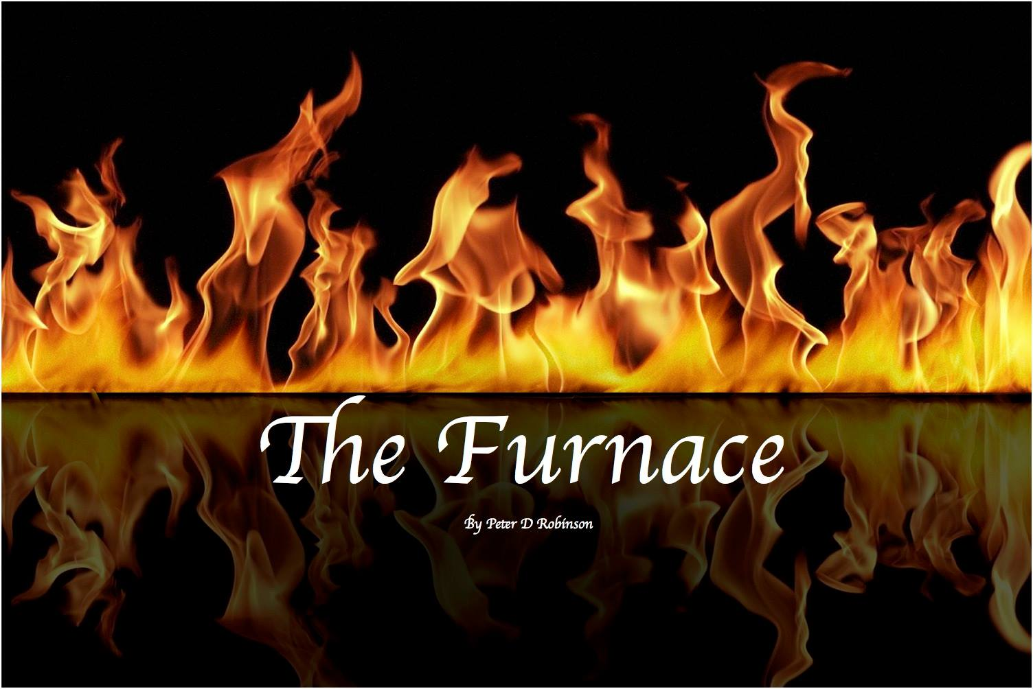

*Saturday 27th August, 2016*

*Just Festival @ St John’s Church*

***The Furnace***is based on the Song of the Three Holy Children, which constitutes a hymn of thanksgiving to God for deliverance from the fiery furnace. Three Hebrew captives, friends of Daniel, Ananias, Azarias and Misael (also known as Shadrach, Meshach and Abednego – names given to them to “help” them assimilate into Babylonian culture) refused to worship a golden idol that king Nebuchadnezzar had created and he ordered them burned to death. However, an Angel of the Lord appeared in the furnace and protected the three young men, causing the king to reconsider, and decree that no man-made god or idol had such power as he had witnessed. He joined in praising the God of Daniel, and issued an edict that no man of any nation should doubt or question the power of God.

The story of the Song of the Three Holy Children is believed by many scholars to have been initially composed in Hebrew or Aramaic. The original manuscripts have been lost but the text survives in the 3rd Century Greek Septuagint as a portion of the Book of Daniel. The seventy Jewish scholars who translated the *Torah* (The Five Books of Moses) into the body of work known as the Septuagint were sponsored by Ptolemy II, some 40 years after the death of Alexander the Great.

In the 16th century, Martin Luther, seminal figure in the Protestant Reformation, concluded – as well as rejecting several teachings and practices of the Roman Catholic Church – that this passage of Daniel was not authentic, and it was thus consigned to the Apocrypha. The King James Version of the Apocrypha includes the admonition *That which followeth is not in the Hebrew*, just in case we are in any doubt.

The Catholic Church fought back; in the Council of Trent (1545-63) they restated what had been agreed in the Councils of Carthage, Synod of 397 AD (28th of August) – viz that this text is dogmatically accepted as canonical.

It seems ironic that a passage devoted to praising God above all others should itself become the focus of schism.

Everything changes and everything remains the same. The world is once again in turmoil: accusations of anti-Semitism within the Labour Party, anti-Muslim sentiment, prejudice and persecution of immigrants, the refugee crisis, Isil attacks, suicide bombings, executions, war in Afghanistan, war in Iraq, war in Syria, the Brexit debacle, and even the American Presidential Campaign.

What is truth? Is it what the newsreader reads from a script? Is it what a tearful eyewitness says to camera? Is it what an angry opinionated neighbour proclaims? Is it what people discuss in the street or the pub? They may all be authentic responses to a situation, but are they equally *true*?

In the miasma of truths of Reality Television and Social Media, with twenty-four-hour rolling news and live streaming of all manner of atrocities, we – as a human race – need to stop and consider. A celebrity is not necessarily a good role model; propaganda masquerades as political spin; teaching and indoctrination are not the same thing; superior firepower and ruthless violence do not make any cause just. We must step back from the brink. Although we are all different, we are all the same. We all bleed the same colour.

***The Furnace***

Soprano Solo – *Veritas* – (The Truth) – Deirdre McFarlane

Tenor Solo – *Profecto* – (The Reality) – David Mitchinson

Baritone Solo – *Imperiam* – (The Official Line) – Paul Castledine

Tenor Solo – *Hananiah* – Greek Text – Colin Povey

Tenor Solo – *Azariah* – Hebrew Text – Peter Robinson

Tenor Solo – *Mishael* – Latin Text – Iain Hughes

Mezzo Solo – The Angel – Katie Fleming

***Choir***

**Soprano Alto Tenor Bass**

Lisa Anderson Morag MacDougall Iain Hughes Paul Castledine

Katie Fleming Nan May David Mitchinson Eric Govan

Kirsty Gillespie Fay McIntosh Iain Morrice John Howden

Eleanor Hubbard Linda Robertson Colin Povey Nigel Orkney

Brodi Orkney Hannah Woolley Peter Robinson Duncan Robertson

Brogan Orkney Alan Woolley

Kenna Orkney

Audrey Westwaters

***Orchestra***

Violin 1 Mairi Holligan, Alison Bell, Aden Mazur, Alison Miller, Danny Miller

Violin 2 Rosemary Delargy, Helen Egan, Alexandria Grant, Ghahaleh Mohammadi-Zaniani

Viola Ben Barclay, April Randall, Eilidh Randall

Cello Chloe Randall, David Shanks

Bass Paige Millar

***Conductor:*** Alan Gibson

***The Song of the Three Holy Children***

Bless the Lord, all ye works of the Lord, praise and exalt Him above all forever.

Bless the Lord all ye heavens; bless the Lord all ye angels of the Lord.

Bless the Lord all ye waters that are above the heavens; let all powers bless the Lord.

Bless the Lord, ye sun and moon; stars of heaven, bless the Lord.

Let the earth bless the Lord; let it praise and exalt Him above all forever.

Bless the Lord, ye mountains and hills; everything growing from the earth, bless the Lord.

Bless the Lord, Israel; praise and exalt Him above all for ever.

Bless the Lord, Ananias, Azaria, and Misael; praise and exalt Him above all for ever.

Let us bless the Father and the Son, with the Holy Spirit; let us praise and exalt Him above all for ever.

With thanks to:

Victoria Hall, Coaltown of Balgonie

Mrs Kinnear

Rami Cohen

Robbie King – rehearsal accompanist

About the Composer

Born and brought up in Edinburgh, Peter studied Music and English at university and, by day, teaches English at Levenmouth Academy in Fife. By night, he is usually involved in music in one form or another. In 2007 he was nominated for Best Composer on the Fringe (MTM:UK awards) for *“Sailing to Tomorrow”* a musical tale of the Highland Clearances performed by Carpe Diem Productions. As a singer and actor, he has performed with companies in Fife and his native Edinburgh, playing roles as diverse as Count Danillo in *“The Merry Widow”,* Sky Masterson in *“Guys and Dolls”*, and the title role in Melvyn Bragg’s *“The Hired Man”.* As Musical Director, Peter has worked on shows from *“Jesus Christ Superstar”* to *“42nd Street”* by way of *“Godspell”* and *“Les Miserables”.* Peter has also had short stories and poetry published, and one of his plays broadcast on Radio. He has written seven musicals based on Scottish historical events and a wide range of vocal, choral and instrumental music.

[www.carpediemproductions.com](http://www.carpediemproductions.com)

This performance is dedicated to the memory of Anne Myrtle, a staunch member of Carpe Diem: with us from the beginning, she will be missed.