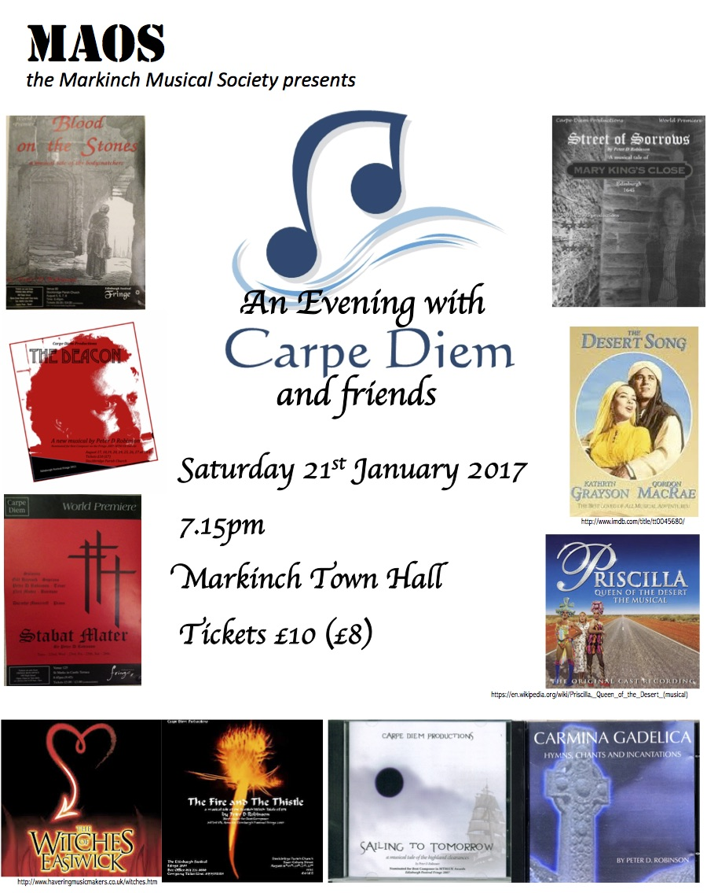

**And So We Gather** – from “The Covenanter” - set in 1650 during the Wars of the Three Kingdoms. Witchcraft, love, bloody battles, deceit, murder and a healthy dose of fire and brimstone bring the events and characters to life at a time when Scotland, and indeed all Europe, was afire with righteous passion and fear in equal measure.

***The Wings of Angels*** – from “The Covenanter” – Major Thomas Weir and his sister, Jean, were convicted on their own confession of being witches. The fact that he was in demand as a precher abd prayer leader on Edinburgh’s *kirky* circuits, only adds grist to the mill. Their incestuous relationship horrified the townspeople almost as much as their confession. “The Covenanter” is set while they are still practising their double lives.

***Three Nights a Week*** – from “The Deacon” – Deacon Brodie, one of the inspirations for Stevenson’s Jekyll and Hyde was famously respectable by day and a successful burglar by night. He also kept a string of women going. All of them were, apparently, quite happy with the arrangement. The show has a narrative like that of “The Beggar’s Opera” of 1728, where the characters in an inn retell the story. The story is set, indeed, while John Gay’s opera is enjoying its success.

***In Your Eyes*** – from “The Deacon” – Lachlan, the character in the inn who doubles as Brodie, has fallen out of love with Rhona Gunn – she has realised this before he does and lets him go.

***The Blessing*** – from “Bothwell’s Bride” – Based on the tormented relationship between Mary, Queen of Scots and her third husband James Hepburn, Earl of Bothwell, the show focuses , on one hand, on the big picture of what’s happening in the country at the time with the increasingly isolated Catholic Mary in dispute with the mainly Protestant Earls – a powerful force meeting an immovable queen. The other facet of the show is the detail of how relationships develop and change on an intimate level as Bothwell invents a reason to divorce his wife in order to be free to marry the queen.

***Different Eyes*** – from “Bothwell’s Bride” – Bothwell wishes that Mary were a little less independent and would ‘let him in’ more frequently, while Mary keeps him at arms length. Having been married twice before (to the young Dauphin of France, who died tragically young, and to Henry, Lord Darnley, a political marriage which she realised was a mistake almost as soon as the vows were spoken), Mary does not want to rush into anything.

***The Prayer*** – from “Bothwell’s Bride” – On the night before her marriage to Bothwell, Mary takes confession. She is about to marry a man who was, not long before, on trial for murdering her last husband. Although Bothwell was acquitted for lack of evidence and swears his innocence, Mary knows this marriage will set the path of the rest of her life.

***Let Me Work on the Hill*** – from “Sailing to Tomorrow” – the action takes place on a sailing ship bound for Australia in 1845 during the Highland Clearances. The men, unused to confinement, lament the land they have left behind; despite the fact that their lives were hard, they knew what was in store as the seasons turned. Here, on the ship, they are certain only of an uncertain future.

***When I’m Walking Along*** – from “Blood on the Stones” – Burke and Hare have gone from body-snatchers to murderers. What do Edinburgh people do in times of trial ? Why, they go to the pub, of course!

***Mountains*** – from “Street of Sorrows” - It is 1645 and the plague is ravaging Europe. Young William King laments that, while he must stay at home and be ‘safe’, his elder brother is free to have adventures. Forbes, the family retainer, tries to reassure him that he will have his chances if he can be patient.

***Shelter Me*** – from “Street of Sorrows” – Mary King’s Close has been sealed off because of the sickness. The council ensures that food is delivered to the close mouth daily, but no one may leave. As the sickness takes hold, the residents of the close turn to God for comfort. James Lockie leads them in heartfelt prayer.

INTERVAL

***Highland Cathedral*** – composed in 1982 by Ulrich Roever and Michael Korb for a Highland Games held in Germany, this pipe tune has quickly become a favourite. One version, recorded by The Royal Scottish Dragoon Guards on the Album “Spirit of the Glen”, won a Classical Brit Award in 2009.

***Colour My World*** – the original song, written by Tony Hatch and Jackie Trent, was a huge hit for Petula Clark in 1966. Its popularity was revived in the motion picture “The Adventures of Priscilla, Queen of the Desert”, released in 1994 and the stage adaption opened in 2006

***Make Him Mine*** – The year 200 saw Cameron Mackintosh’s production of “The Witches of Eastwick” open in the West End. Three lonely women seeking love, accidentally make a deal with the devil and find they have magical powers. The devil finds out he’s no match for these three witches!

***Motown*** – **singalong** – Originally named Tamla Records, the Motown label became synonymous with a certain sound, a real 60s groove and brought the world some huge stars. Let your hair down; smell the flowers; join in!

***Back to Before*** – from “Ragtime”, which opened in 1996 on Toronto. In the turn of the 20th Century New York an era of change is exploding and, in its crucible, ragtime music is born. Based on the novel by E.L Doctorow, Ragtime weaves together the story of three groups in America, represented by Coalhouse Walker Jr, a Harlem musician; Mother and her white, middle class family in New Rochelle; and Tateh, a Jewish immigrant who has come to America with his daughter seeking a new life. Their fictional lives become dramatically intertwined with one another as well as with historical figures including Harry Houdini, Booker T. Washington, JP Morgan and Henry Ford. Near the close of the show, as the ragtime era draws to a close, Mother realises there no point looking back; there is only forward.

***One Alone*** – Inspired by the 1925 uprising of the Riffs, a group of Moroccan fighters, against French colonial rule and the tales of Lawrence of Arabia, with music by Sigmund Romberg and lyrics by Oscar Hammerstein II, the original production of “The Desert Song” opened on Broadway in 1926. The first leading man was a Scot, Richard Halliday.

***Unusual Way*** – Based on Federico Fellini’s semi-autobiographical film “81/2”, the musical “Nine” began life as a class-project in a musical theatre workshop in 1973 and was later developed further by its creator, Maury Yetson, and went on to win five Tony Awards. The live-action film adaptation, featuring some stellar names was released in 2009. Claudia, a film star, and muse of Guido, realising that he can never love her in the way she needs, chooses to walk away with her head held high.

***Façade*** – “Jekyll and Hyde” hinges on the two natures of man as epitomised by the tragic Doctor Jekyll of Robert Louis Stevenson’s novel. A central concern of the musical, which opened on Broadway in 1997, is that there is something lurking in all of us behind the façade we present to the world.

***At The End of The Day*** – “Les Miserables” opened in Paris in 1980, a sung-through musical based on the (very long) novel by Victor Hugo. In a time of contrasts, the poor are down-trodden and desperate while the rich are oblivious in their cocoon of wealth. Justice and honour are things ordinary people can’t afford.

***Omens*** – Over a hundred years ago, the culmination of Alexander Carmichael’s life’s work came to fruition with the publication of Carmina Gadelica. Orally collected in the Highlands and Islands of Scotland, Carmina Gadelica comprises English translations of traditional Gaelic hymns, chants, and incantations transcribed lest they be lost forever as the Gaelic language was every swifter squeezed out of use in Scotland: these religious texts contain a strange blend of pagan, Celtic, and Christian imagery.

***In Paradisum*** – “The Stabat Mater” is a 13th century prayer meditating on the sorrows of the Virgin Mary in her station at the cross. This setting, unusually, ends with In Paradisum (also a traditional text but not normally associated with the Stabat Mater). It seems a fitting close to the piece since it is a celebration of the assured entry into heaven which Christ’s sacrifice gives to all believers.

***Choices*** – from “The Fire and The Thistle” – set during the Scottish Witch Trials of 1592, the show follows the progression towards execution of Gillie Duncan, a housemaid of Tranent. James I and his wife Anne, having recently survived a treacherous crossing of the Forth – believed to have been summoned by witches are conflicted when they meet Gillie because she seems kind and gentle. The Earl of Bothwell (another one – a favourite of the king – has met Gillie previously and taken advantage of her. In this song all four of them ponder the choices they have made.

***Mistakes*** – Near the end of “The Fire and the Thistle”, although Gillie has been condemned to death, Anne and the King have taken pity on her and ask that she be treated kindly before her execution. John Kerr, a trusted servant of the king, has been sent to bathe her wounds and offer her some small comfort.

***A New Tomorrow*** – from “Sailing to Tomorrow”, despite all that has been left behind, despite having been driven off their land and out of their native land, the passengers on the ship turn their faces forwards and look with hope to the new lives ahead of them.

**Carpe Diem Productions** was formed to perform the works of Scottish composer Peter D Robinson: MTM Musical Theatre Awards nominee for Best Composer - "Sailing to Tomorrow" 2007. Carpe Diem brings together singers and players from all over central Scotland, from all backgrounds and from all walks of life. The connecting factor is an enjoyment of Peter's music and a desire to have it experienced by a wider audience. Regular appearances at the Edinburgh Fringe help bring this dream to life.

Learn more at www.carpediemproductions.org

Peter studied Music and English at university and teaches English at a Fife secondary school. As a singer and actor, he has performed with many companies in Edinburgh and Fife, and is often to be found in the pit as MD for amateur Musical and Operatic companies

**Sopranos Altos Tenors**

Lisa Anderson Steph Baillie Iain Hughes

*Elaine Barlow Margaret Kinnear David Mitchinson

Jackie Beatson Louise May-Short Iain Morrice

Kirsty Gillespie Nan May Colin Povey

Margaret Goldie Fay McIntosh Peter Robinson

Elinor Hay Margo McKay Craig Spence

Elspeth Hay Morag MacDougall

Brogan Orkney Linda Robertson **Basses**

Brodi Orkney Laura Spence Duncan Robertson

Kenna Orkney Julie Stirling Alan Woolley

Karen Skene Diane White

Janet Spittal Janice Wilkie

Audrey Westwaters Hannah Woolley

*denotes soloist

Keyboards: Dorothy Moncrieff and Robbie King

Thanks to:

Mrs Kinnear – Victoria Hall, Coaltown of Balgonie

MAOS – the Markinch Musical Society